### Internship 2022

# Progress report format for team meeting

Name: Cynthia Kemboi

## Tasks completed last week

* [#15] Redesign of the chassis diagram- Done using AutoCAD software for tolerance purposes.
* [#22] Laser cutting of the chassis- Brief overview of the laser cutting machine and how it relates to the corel draw software. The design of the chassis to be cut was imported to the Corel Draw software and it was cut from an extruded acrylic material.
* [#23]3D design of the chassis and motor mounts- SolidWorks software was used to draw the mounts and they’ll be used to lock the motors to the chassis and also join the upper and lower chassis using fasteners.

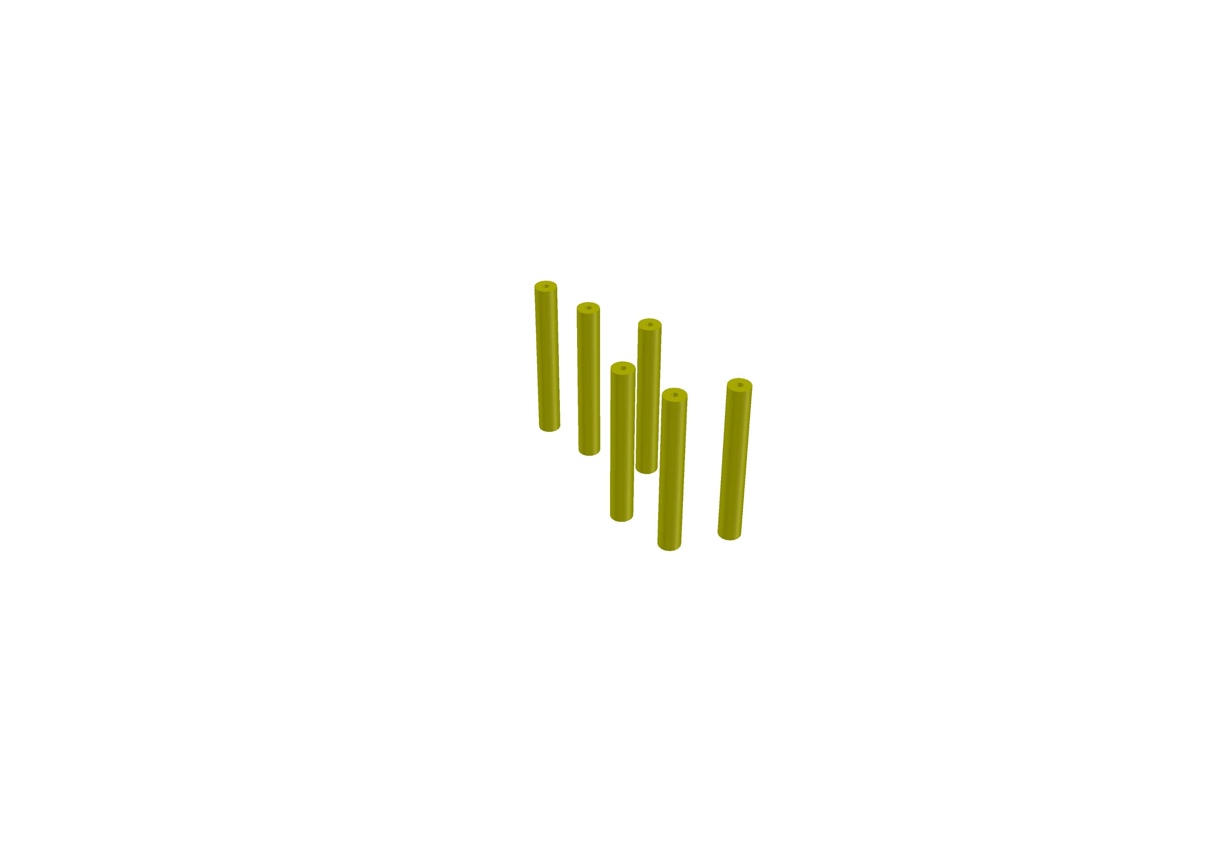

Chassis holders

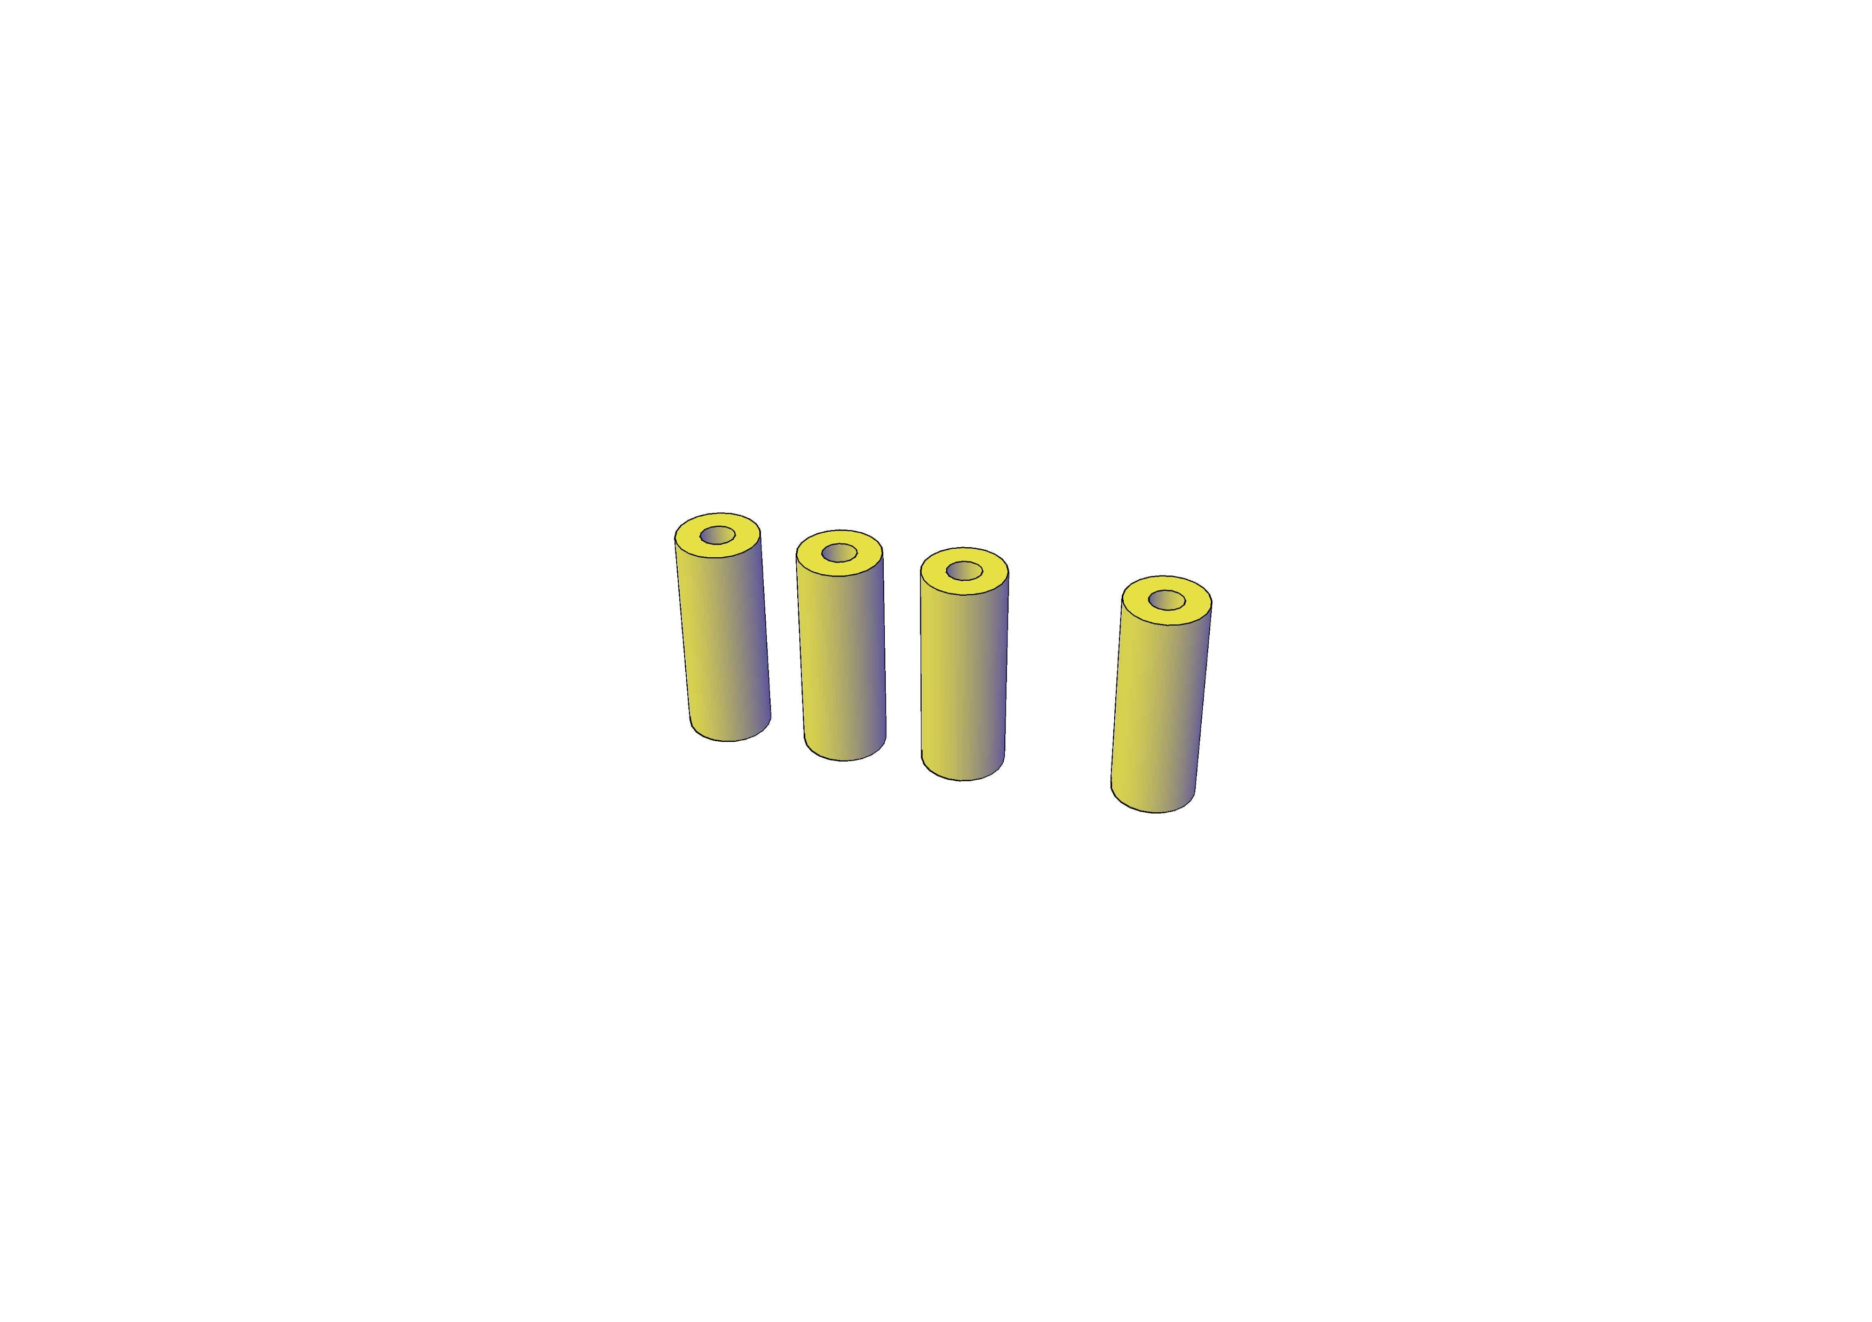

Motor holders

## Tasks in this week

* [#24]3D printing of the mounts
* [#25] Obstacle avoidance using ultrasonic sensor
* [#26] Obstacle avoidance using computer vision
* [#29]Material selection for 3D prnting.

## Timeline

|  |  |  |
| --- | --- | --- |
| Month | Intern week | Tasks |
| Jan |  |  |
| Week 1 | Identification of parts and drawing of the chassis diagram |
| Week 2 | Circuit diagram and acquisition of parts. |
| Week 3 | Definition of the path to be followed by the robot car |
| Feb | Week 4 | 3D printing of motor and chassis mounts  Redesigning of chassis |
| Week 5 | Assembling of components |
| Week 6 | Designing of the farm implements to be used |
| Week 7 | Testing the functionality of the robot tractor and make any necessary changes |
|  | Week 8 | Have a robot tractor that accomplishes the required mission, which is navigation and tillage. |